COMSATS University Islamabad, Islamabad Campus



Secure Software Design and Development
Lab Final

Architecture Blueprint

Student Names | Muhammad Awais , Muhammad Umair Nazir , Muhammad Umar
Registration Numbers | SP23-BCT-008 , SP23-BCT-038 , SP23-BCT-040
Submission Date | 12 June 2026
Submitted To | Mr Muhammad Ahmed Nawaz

Contents
SecureGrade Student Result Portal 3
1. Introduction 3
2. System Overview 3
Core Design Principles 3
3. C4 Model 3
3.1 Level 1 — System Context Diagram 4
Actors & Interactions 4
3.2 Level 2 — Container Diagram 5
Container Descriptions 5
Inter-Container Communication 6
3.3 Level 3 — Component Diagram (Auth Service) 7
Auth Service Components 8
4. Zero Trust Architecture 9
4.1 Zero Trust Principles Applied 9
Principles & Implementation 10
4.2 Trust Zones 11
4.3 Authentication Flow (Zero Trust) 11
5. SABSA Architecture 11
6. Docker Architecture 12
6.1 Containerization Strategy 12
6.2 Multi-Stage Build Process 13
6.3 Docker Security Controls 14
7. Kubernetes Architecture 14
7.1 Cluster Layout 14
Namespace Design 15
7.2 Kubernetes Security Controls 16
7.3 Network Policy Design 16
8. Security Design Decisions 17
9. Framework Compliance Summary 17

SecureGrade Student Result Portal

1. Introduction
The Architecture Blueprint defines the secure design of the SecureGrade Student Result Portal. This document covers the system's structural design using the C4 Model, Zero Trust principles, SABSA framework, Docker containerization, and Kubernetes orchestration. Every architectural decision is driven by security-by-design principles established in Phase 1 threat modelling.

2. System Overview
Application: SecureGrade — Student Result Portal
Architecture Style: Cloud-native, microservices-based, event-driven
Deployment: Docker containers orchestrated by Kubernetes
Security Model: Zero Trust — never trust, always verify

Core Design Principles
Principle | Application
Security by Design | Security controls built into architecture, not added after
Zero Trust | Every request verified regardless of source or location
Least Privilege | Every user, service, and process gets minimum required access
Defence in Depth | Multiple security layers — no single point of failure
Separation of Concerns | Each microservice handles one responsibility only
Assume Breach | Continuous monitoring assumes attacker may already be inside

3. C4 Model
The C4 Model provides four levels of architectural diagrams, each zooming progressively deeper into the system.

3.1 Level 1 — System Context Diagram
The System Context diagram shows SecureGrade and its relationships with external users and systems. It answers the question: who uses the system and what does it connect to?
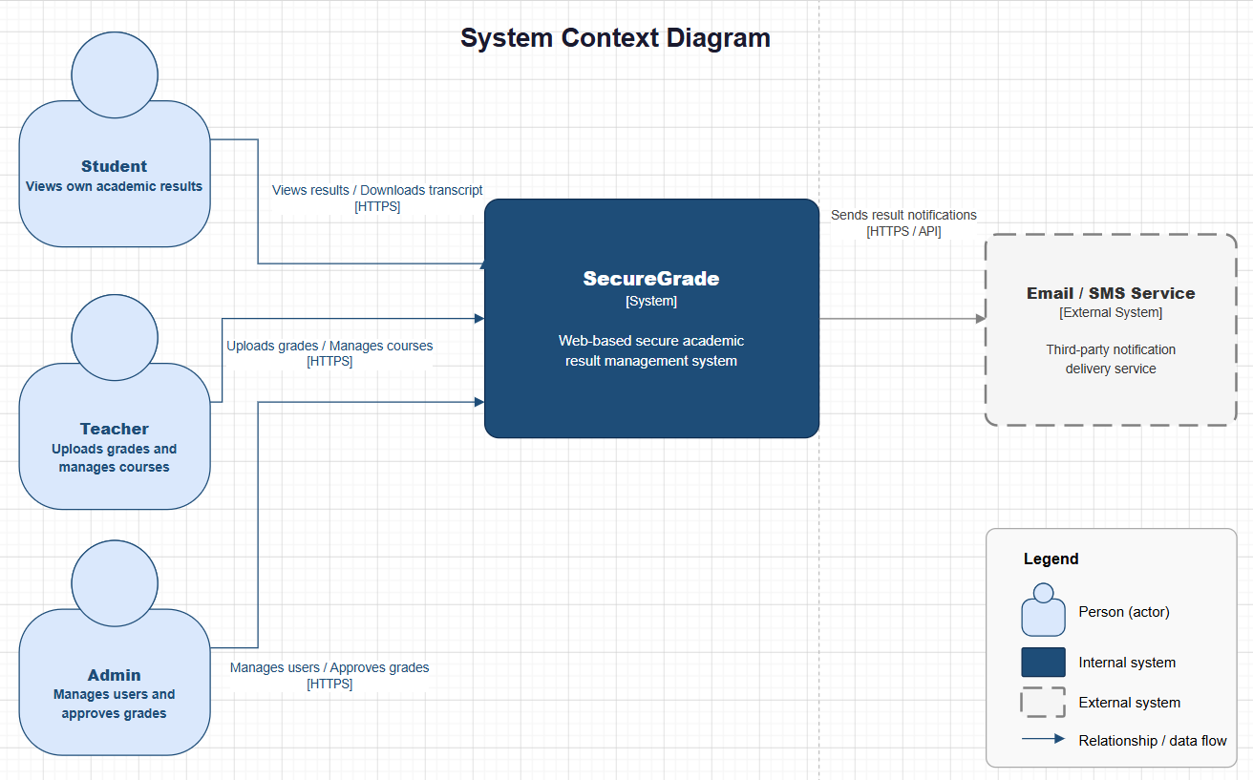

Actors & Interactions
Actor | Type | Interaction
Student | Internal User | Views results, downloads transcripts
Teacher | Internal User | Uploads grades, manages course results
Admin | Internal User | Manages users, approves grades, views audit logs
Email/SMS Service | External System | Receives notification requests from portal

3.2 Level 2 — Container Diagram
The Container diagram shows all deployable units within the SecureGrade system boundary. Each container runs as an independent Docker container orchestrated by Kubernetes.

Container Descriptions
Container | Technology | Responsibility | Security Control
Web Frontend | React.js | UI for all roles | CSP headers, XSS prevention
API Gateway | Nginx/Kong | Routing, TLS termination, rate limiting | WAF, JWT verification
Auth Service | Node.js | Login, JWT, MFA, session management | bcrypt, TOTP, RS256 JWT
Result Service | Node.js | Grade viewing, access enforcement | RBAC, ABAC, IDOR prevention
Grade Service | Node.js | Grade upload, CSV processing | Input validation, file scanning
Admin Service | Node.js | User management, grade approval | Step-up auth, audit logging
Notification Service | Node.js | Email/SMS on result publish | Kafka consumer, rate limited
PostgreSQL | Database | All persistent application data | Encryption at rest, mTLS
Redis | Cache | Session tokens, JWT blacklist | TLS, encrypted, no persistence of PII
Apache Kafka | Event Bus | Async events between services | TLS, ACLs, Schema Registry
HashiCorp Vault | Secrets Manager | All credentials and signing keys | Dynamic secrets, lease expiry
MinIO | Object Storage | Transcript PDF files | Encrypted, access-controlled

Inter-Container Communication
From | To | Protocol | Purpose
API Gateway | All Services | HTTPS + JWT | Authenticated routing
Auth Service | PostgreSQL | mTLS | User credential lookup
Auth Service | Redis | TLS | Session storage
Auth Service | Vault | mTLS | JWT signing key retrieval
Grade Service | Kafka | TLS | Publish GradeUploaded event
Kafka | Notification Service | TLS | Consume ResultPublished event
All Services | Vault | mTLS | Dynamic secret retrieval
All Services | Loki | TLS | Audit log shipping
From | To | Protocol | Purpose
Result Service | PostgreSQL | mTLS | Grade and result data retrieval
Admin Service | PostgreSQL | mTLS | User management and grade approval queries
Admin Service | MinIO | mTLS | Transcript PDF retrieval and storage

3.3 Level 3 — Component Diagram (Auth Service)
The Component diagram zooms into the Auth Service, showing its internal structure and how components interact.

Auth Service Components
Component | Responsibility
Login Controller | Handles POST /api/auth/login, orchestrates login flow
MFA Controller | Validates TOTP codes for teacher and admin roles
JWT Generator | Issues RS256-signed JWT with role and subject claims
TOTP Validator | Verifies time-based OTP, enforces 30-second window
Session Manager | Creates and invalidates Redis sessions on login/logout
Password Handler | bcrypt hashing (cost factor 12) and verification
Audit Logger | Logs every auth event with IP, timestamp, user agent
Token Blacklist | Tracks invalidated JWT tokens in Redis until expiry

4. Zero Trust Architecture

4.1 Zero Trust Principles Applied
Zero Trust operates on the principle of "never trust, always verify." Every request — even internal service-to-service calls — must be authenticated and authorized before access is granted.
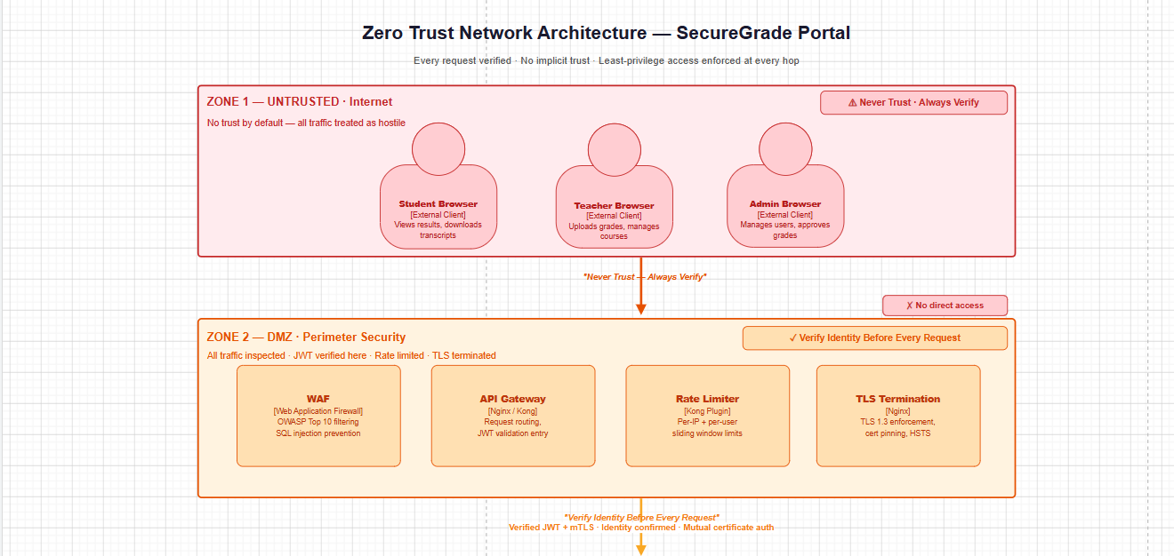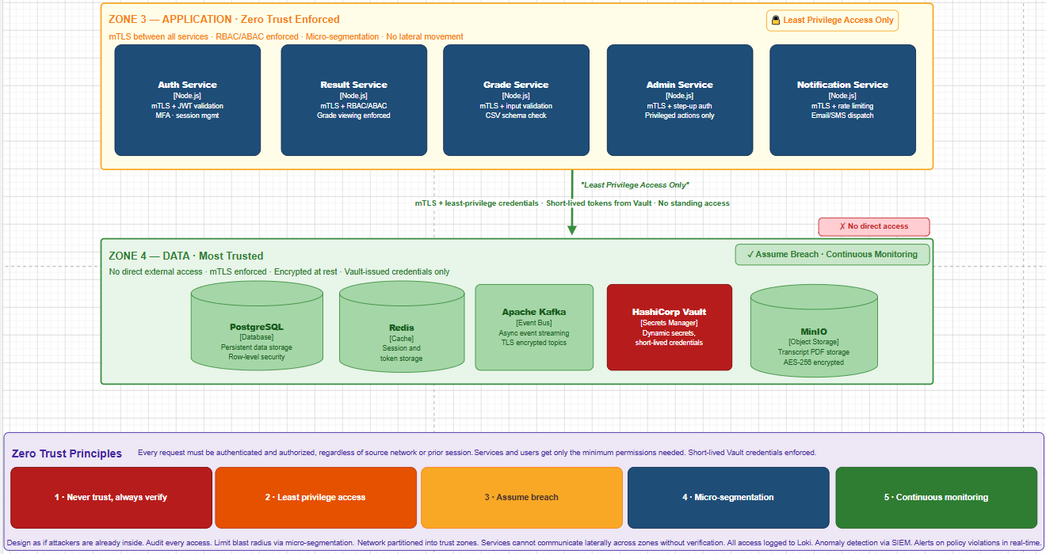

Principles & Implementation
Zero Trust Principle | Implementation in SecureGrade
Never trust, always verify | JWT validated on every API call including internal service calls
Least privilege access | RBAC/ABAC ensures users and services access only what they need
Assume breach | Falco monitors runtime, QRadar detects anomalies continuously
Verify explicitly | MFA for teacher/admin, step-up auth for all critical admin actions
Micro-segmentation | Kubernetes Network Policies isolate pods by namespace and role
Continuous monitoring | Prometheus, Loki, Falco, and QRadar active at all times

4.2 Trust Zones
Zone | Components | Trust Level | Access Rule
Untrusted | Internet, all browsers | Zero trust | No direct access to any service
DMZ | WAF, API Gateway, Rate Limiter | Low trust | Inspect and filter all traffic
Application | All microservices | Medium trust | mTLS + valid JWT required
Data | PostgreSQL, Redis, Kafka, Vault | High trust | mTLS + least privilege credentials only

4.3 Authentication Flow (Zero Trust)
Every Request Must Pass:

Step 1 → TLS 1.3 verified at API Gateway
Step 2 → JWT signature verified (RS256)
Step 3 → JWT expiry checked (15 min window)
Step 4 → JWT claims checked (role, subject, scope)
Step 5 → RBAC policy evaluated
Step 6 → ABAC policy evaluated (resource-level)
Step 7 → Request allowed or denied
Step 8 → Action logged to audit trail

5. SABSA Architecture
SABSA (Sherwood Applied Business Security Architecture) provides a business-driven framework for designing security architecture across six layers.
SABSA Layer | Question Answered | Application to SecureGrade
Contextual | Why do we need security? | Protect academic integrity, student privacy, legal compliance
Conceptual | What security do we need? | Zero Trust, need-to-know access, tamper-evident grade records
Logical | How do we achieve it? | RBAC, ABAC, JWT, MFA, TLS, audit logging, input validation
Physical | What mechanisms implement it? | AES-256, bcrypt, TLS 1.3, RS256 JWT, HashiCorp Vault
Component | What tools do we use? | Docker, Kubernetes, PostgreSQL, Redis, Kafka, Falco, QRadar
Operational | Who manages it? | DevSecOps team, automated CI/CD pipeline, QRadar alerts

6. Docker Architecture

6.1 Containerization Strategy
Every microservice is packaged as a hardened Docker container following security best practices and CIS Docker Benchmark guidelines.
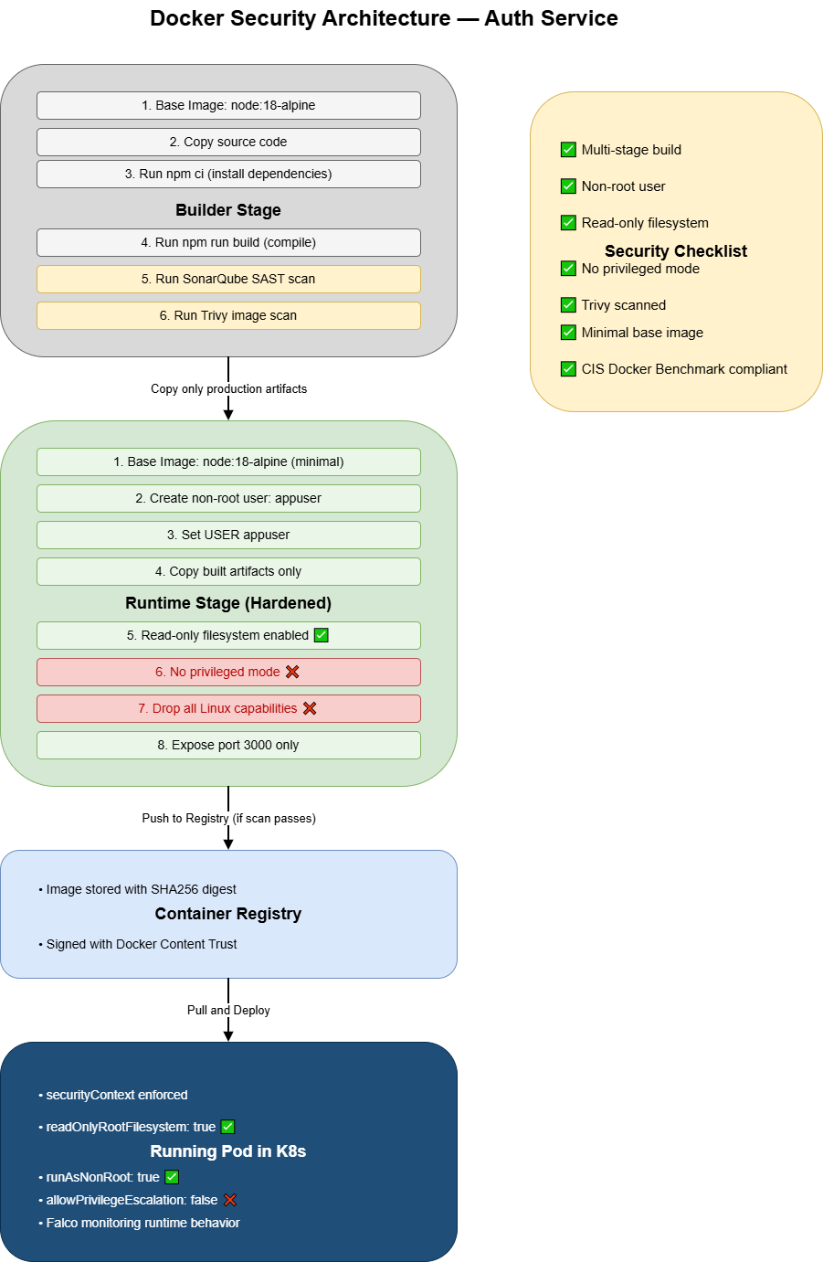

6.2 Multi-Stage Build Process
All Docker images use multi-stage builds to minimize attack surface:
Stage 1 — Builder:
→ Full Node.js image with build tools
→ Install all dependencies
→ Compile and build application
→ Run SAST scan (SonarQube/CodeQL)

Stage 2 — Runtime (Hardened):
→ Minimal Alpine base image only
→ Copy compiled artifacts only
→ No build tools, no package managers
→ Run as non-root user
→ Read-only filesystem

6.3 Docker Security Controls
Security Control | Implementation
Non-root user | RUN adduser appuser + USER appuser in Dockerfile
Read-only filesystem | --read-only flag, writable tmpfs only where needed
No privileged mode | privileged: false enforced by Kyverno policy
Minimal base image | node:18-alpine — smallest possible attack surface
Image scanning | Trivy scans every image before deployment
No hardcoded secrets | All secrets fetched from Vault at runtime
CIS Docker Benchmark | All containers validated against CIS controls

7. Kubernetes Architecture

7.1 Cluster Layout
The Kubernetes cluster is divided into four namespaces, each with strict Network Policies controlling inter-namespace communication. 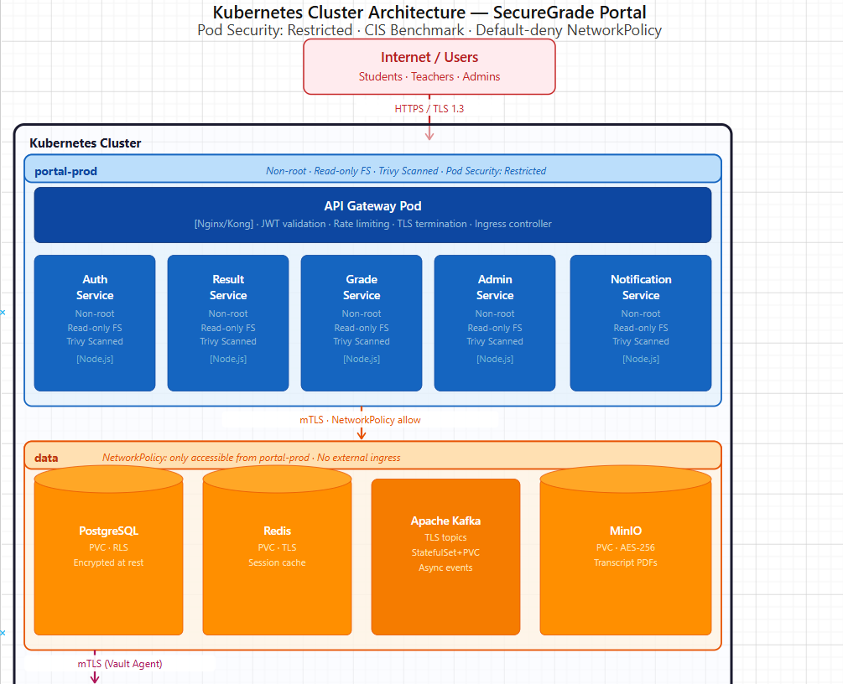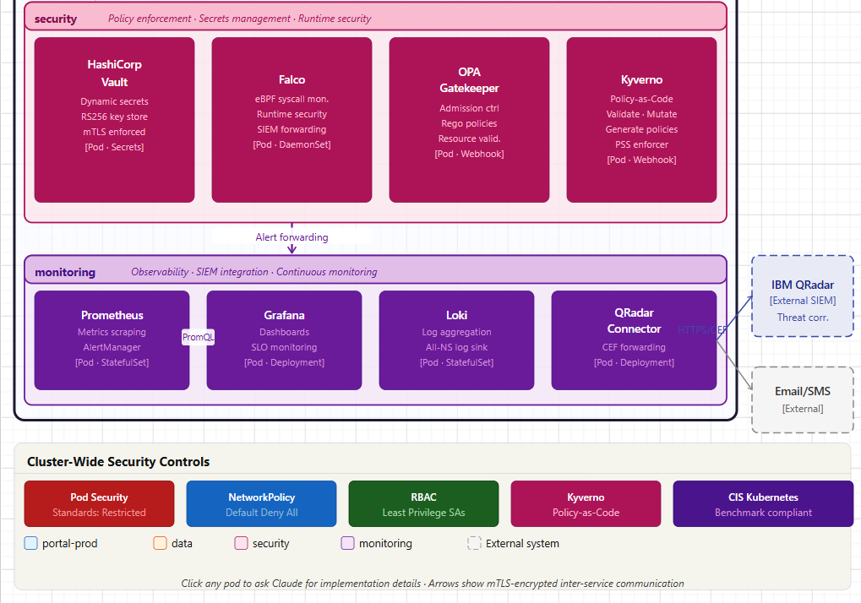

Namespace Design
Namespace | Contents | Network Policy
portal-prod | All application microservices | Can talk to data namespace only
data | PostgreSQL, Redis, Kafka, MinIO | Only accessible from portal-prod
security | Vault, Falco, OPA, Kyverno | Accessible by all namespaces (read-only)
monitoring | Prometheus, Grafana, Loki, QRadar connector | Receives metrics/logs from all namespaces

7.2 Kubernetes Security Controls
Control | Implementation | Purpose
Pod Security Standards | restricted profile enforced | Blocks privileged containers cluster-wide
Network Policies | Default deny-all, whitelist only | Pods only communicate with explicitly allowed pods
RBAC | Scoped service accounts per pod | Each pod has minimum required API permissions
Kyverno Policies | Policy-as-Code enforced at admission | Auto-rejects non-compliant pod configurations
OPA Gatekeeper | Constraint templates applied | Enforces custom security constraints
RuntimeClass | gVisor sandbox for sensitive pods | Extra isolation for auth and data services
Secret Management | Vault Agent Injector | No Kubernetes secrets used — all from Vault
CIS Benchmark | kube-bench automated scanning | Validates cluster against CIS Kubernetes Benchmark

7.3 Network Policy Design
Default Rule: DENY ALL ingress and egress

Explicit Allow Rules:
→ Internet → API Gateway pod (port 443 only)
→ API Gateway → portal-prod pods (port 3000, JWT required)
→ portal-prod → PostgreSQL (port 5432, mTLS)
→ portal-prod → Redis (port 6379, TLS)
→ portal-prod → Kafka (port 9092, TLS)
→ portal-prod → Vault (port 8200, mTLS)
→ All pods → Loki (port 3100, log shipping)
→ Prometheus → All pods /metrics (port 9090, scraping)
→ Falco → QRadar (port 514, alert forwarding)

8. Security Design Decisions
Decision | Justification
Microservices over monolith | Breach of one service does not compromise entire system
JWT over session cookies | Stateless, scalable, works across microservices
RS256 over HS256 for JWT | Asymmetric signing — private key never leaves Vault
Redis for sessions | Fast invalidation on logout, TTL-based expiry
Kafka for events | Decouples services, tamper-evident event log
Vault for secrets | No hardcoded credentials anywhere in codebase
Alpine base images | Minimal packages = minimal CVEs
Separate namespaces | Blast radius containment if one namespace is compromised
mTLS between services | Both sides verify identity — prevents rogue service injection
OPA + Kyverno together | OPA for business logic policies, Kyverno for K8s resource policies

9. Framework Compliance Summary
Framework | Architecture Elements Covered
NIST SP 800-207 | Full Zero Trust implementation across all zones
NIST SP 800-160 | Security-by-design in all architectural decisions
SABSA | All six layers addressed in Section 5
CIS Docker Benchmark | All controls applied in Section 6.3
CIS Kubernetes Benchmark | All controls applied in Section 7.2
OWASP ASVS V1 | Architecture, design and threat modelling requirements met
ISO/IEC 27034 | Application security controls mapped across all microservices and API endpoints
CSA CCM | Cloud security controls applied across IAM, encryption, logging, and infrastructure

